NETWORK FUNDAMENTALS AND BUILDING NETWORKS

NETWORK DEVICES

TASK1: Draw and label a simple home network diagram showing a router, switch, and three devices (like a laptop, smartphone, and smart TV), indicating how each device connects to the network.
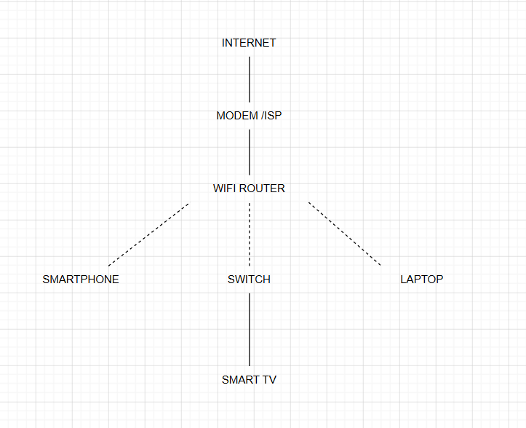

TASK2: Create a comparison table listing at least four network devices (router, switch, hub, access point) and describe one real-world use case for each, referencing apps or services you use daily (e.g., WiFi for streaming on YouTube, LAN gaming, etc.).
Network Device | Main Function | Real-World Use Case
Router | Connects the home network to the Internet | Used at home for YouTube, Instagram, and online gaming
Switch | Connects multiple wired devices in a LAN | Used in a computer lab for LAN gaming and file sharing
Hub | Sends data to all connected devices | Used in small or old networks (rare today)
Access Point (AP) | Extends or provides Wi-Fi coverage | Used in colleges, offices, and malls to provide Wi-Fi access

TASK3: Write a short scenario where you explain how data travels from your phone to the internet when you order food on Zomato, mentioning the role of each network device involved (router, switch, access point).
- I open the Zomato app on my phone and search for food.
- My phone sends the request through the Access Point (Wi-Fi).
- The request reaches the Router, which sends it to the Internet through the ISP.
- If a Switch is used in the network, it transfers data between wired devices.
- The request reaches the Zomato server, which processes it and sends the results back to my phone through the same path.

TASK4: Given this situation: you have a WiFi router, but your gaming PC only has an Ethernet port and is far from the router. Suggest two different network devices you could use to connect your PC to the internet and explain how each would work in this setup.<br><br><em><strong>Hint:</strong> Think about devices like switches, powerline adapters, or WiFi extenders.</em>
SOLUTION 1: WIFI EXTENDED
A Wi-Fi extender receives the Wi-Fi signal from the router and extends it to another area. The gaming PC can then connect to the extender using an Ethernet cable.
SOLUTION2:POWER ADAPTER
A powerline adapter uses the home's electrical wiring to carry the Internet connection. One adapter connects to the router, and the other connects to the gaming PC using an Ethernet cable.

